Slide 1 — What is Beonedge?
Beonedge Wealth Management
Beonedge is a research-driven wealth management firm focused on helping investors grow their capital through disciplined investing and strategic asset allocation.
We allocate client capital across:
• Equity Markets
• Commodities
• Fixed Income Instruments
Our objective is to generate sustainable long-term returns by combining:
• Deep fundamental research
• Risk-managed portfolio construction
• Strategic asset allocation
We aim to help investors grow their hard-earned money beyond traditional investment options such as bank deposits and passive index returns, while maintaining a disciplined approach to risk.

Slide 2 — Our Aim & Investment Philosophy
At Beonedge, our philosophy is built on two core principles.
1. Consistent Wealth Creation
Our long-term goal is to deliver returns that outperform benchmark indices and traditional savings instruments through disciplined investing.
Expected long-term target range:
12–15% CAGR over market cycles
This is achieved through:
• Strategic asset allocation
• Fundamental research
• Risk management
• Market cycle awareness

2. Capital Protection First
Preserving client capital during adverse market conditions is equally important as generating returns.
Our investment strategy focuses on:
• Managing downside risk
• Reducing volatility during market stress
• Protecting capital during extreme market conditions

Slide 3 — Services We Provide
Beonedge offers multiple investment options depending on investor requirements.
1. Systematic Investment Plan (SIP)
A disciplined investment approach where investors contribute a fixed amount periodically.
2. One-Time Investment
For investors who want to deploy capital at once and stay invested for the long term.
3. Portfolio Management Service (PMS)
Customized portfolio management for larger investors with performance-linked profit sharing.

Slide 4 — Modes of Investment
1. SIP (Systematic Investment Plan)
• Minimum Investment: ₹500 per month
• Minimum Duration: 12 months
Investors choose a fixed amount that will be invested automatically every month on a predetermined date.
Example:
4th of every month
This method promotes discipline and long-term wealth creation.

2. One-Time Investment
• Minimum Investment: ₹10,000
• Minimum Holding Period: 12 months
This is suitable for investors who wish to deploy capital in a lump sum and participate in long-term market growth.

3. Portfolio Management Service (PMS)
• Minimum Capital: ₹5,00,000
Our PMS model is performance based.
• Profit sharing applies only after outperforming benchmark returns
• If benchmark returns are not beaten → no commission
This ensures complete alignment between investor and manager performance.

Slide 5 — Why Choose Beonedge?
Experienced Market Participation
Our team has actively participated in financial markets for over 5 years, navigating multiple market cycles including:
• COVID-19 market crash
• Russia-Ukraine geopolitical volatility
• Bull market phases of 2023–2024
• Current evolving market conditions

Strong Performance Track Record
We have maintained an average CAGR of approximately 16% over the last 5 years through disciplined investing.
A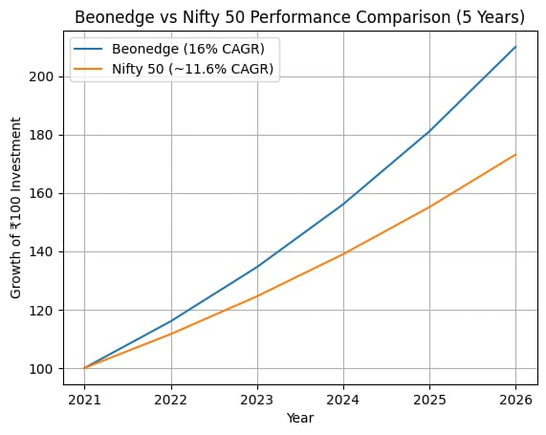
A ₹100 investment growing at 16% CAGR reaches approximately ₹210 in 5 years, compared to around ₹176 at 12% CAGR benchmark growth.
This highlights the power of consistent alpha generation over time.
Research-Driven Approach
Our investment strategy is built on:
• Deep fundamental research
• Market data analysis
• Statistical and algorithmic models developed internally
• Continuous monitoring of market trends and macro factors
Since our portfolio focuses primarily on Indian equities, we develop deeper sector expertise and research advantage.

Beonedge Asset Allocation Framework
At Beonedge, capital is allocated across multiple asset classes to balance growth, stability, and risk management.
Asset Class | Allocation Range | Objective
Indian Equities | 50–70% | Long-term capital growth
Commodities | 10–20% | Hedge against inflation and macro shocks
Fixed Income | 10–25% | Stability and capital protection
Cash / Tactical | 5–10% | Opportunities during market corrections

Key Principles
• Diversification across asset classes
• Dynamic allocation based on market conditions
• Focus on high-conviction investments
• Risk-adjusted portfolio construction
Asset allocation is one of the most important drivers of long-term investment returns.
Slide 6 — What We Do NOT Do
At Beonedge, transparency and integrity are core values.
We do not:
• Promise unrealistic or guaranteed returns
• Offer trading tips or speculative recommendations
• Claim to double or triple money
• Run Telegram or signal groups
• Encourage short-term speculation
Our focus remains strictly on long-term disciplined wealth creation.

Slide 7 — Client Investment Tracking
We believe investors should have complete transparency regarding their investments.
Beonedge has developed a dedicated client portal where investors can:
• Track their investments
• Monitor portfolio performance
• View transaction history
• Stay updated on portfolio allocation
This platform is currently available for clients and will soon be expanded with a full public website and landing page.

Slide 8 — Contact Us
Beonedge Wealth Management
📍 Address
College Road, Powarh
Ghatsila – 832303
📞 Phone
8789136062
6201907898
🌐 Website
beonedge.in

